Baby Corey_CMFS015H__FCS
Coriolis Flowmeter Calculation Summary |  |  |  |  |  | Quote/Rev No: |  |  |  | -/-
Date: |  |  |  | ‭2023-03-30‬
Company: |  |  |  | -
Project Name: |  |  |  | Fall 2022 Campaign
Service: |  |  |  | -
Sensor Model Name : |  |  |  | CMFS015H
Sensor Model #: |  |  |  | -
Sizing Name: |  |  |  | Baby Corey
Transmitter Model Name : |  |  |  | -
Transmitter Model #: |  |  |  | -
Transmitter Tag(s): |  |  |  | -
Wetted Material: |  |  |  | Alloy C22
Fluid: |  |  |  | GULF COAST NATURAL GAS
Fluid State: |  |  |  | Gas
K(Flow Consistency Index) |  |  |  | -
n(Flow Behavior) |  |  |  | -
Mass Flow Accuracy (+/- % of Rate) |  |  |  | 00.2500
Pressure Drop at Operating Flow |  |  |  | 0.7367 | psig
Velocity at Operating Flow |  |  |  | 16.4796 | m/sec
 |  |  |  | Min | Operating* |  |  | Max |  |  | Design |  | Units
Flow Rate: |  |  |  | 0.2000 | 5.0000 |  |  | 10.0000 |  |  | - |  | kg/hr
Pressure: |  |  |  | - | 150.0000 |  |  | - |  |  | - |  | psig
Process Fluid Temperature: |  |  |  | - | 50.0000 |  |  | - |  |  | - |  | F
Ambient Temperature: |  |  |  | - | 68.0000 |  |  | - |  |  | - |  | F
Density: |  |  |  | - | 0.5192 |  |  | - |  |  | 0.0000 |  | lb/ft3
Viscosity: |  |  |  | - | 0.0103 |  |  | - |  |  | - |  | cP
Gas Only | Base Reference Temperature: |  | F | 60.0000
Gas Only | Base Reference Pressure: |  | psia | 14.6960
Gas Only | Base Reference Density: |  | lb/ft3 | 0.0440
Process Connection: |  |  |  | -
Process Connection Pressure Rating: |  |  |  | -
@Temperature: |  |  |  | 50.0000 F
Flow Rate | kg/hr | Mass Flow Accuracy (+/- % of Rate) |  | Pressure Drop* | psig |  | Velocity at Operating Flow |  | m/sec |  |  | Re
10.0000 |  | 00.2500 |  | 2.6992 |  |  | 32.9592 |  |  |  |  | 67802.2340
9.0200 |  | 00.2500 |  | 2.2214 |  |  | 29.7292 |  |  |  |  | 61157.6151
8.0400 |  | 00.2500 |  | 1.7888 |  |  | 26.4992 |  |  |  |  | 54512.9961
7.0600 |  | 00.2500 |  | 1.4015 |  |  | 23.2692 |  |  |  |  | 47868.3772
6.0800 |  | 00.2500 |  | 1.0600 |  |  | 20.0392 |  |  |  |  | 41223.7583
5.1000 |  | 00.2500 |  | 0.7643 |  |  | 16.8092 |  |  |  |  | 34579.1393
4.1200 |  | 0.2748 |  | 0.5150 |  |  | 13.5792 |  |  |  |  | 27934.5204
3.1400 |  | 0.3606 |  | 0.3126 |  |  | 10.3492 |  |  |  |  | 21289.9015
2.1600 |  | 0.5242 |  | 0.1582 |  |  | 7.1192 |  |  |  |  | 14645.2825
1.1800 |  | 0.9595 |  | 0.0535 |  |  | 3.8892 |  |  |  |  | 8000.6636
0.2000 |  | 5.6608 |  | 0.0025 |  |  | 0.6592 |  |  |  |  | 1356.0447
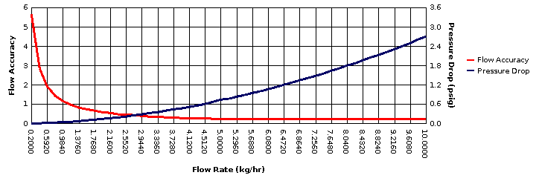
* All pressure drop and velocity results are based on the process conditions (except flow rate) that are entered in the Operating column.

